**Ansible Ideal Installation**

* **Pick the Instances Main & Agent**: AMI ID: CentOS Linux 7 (ami-01d5b8c6e4958a724
* **First Command**: sudo su
* **Set Host Names in Main and Agent Instances**: **hostname** Nameofinstance & **exec bash**
* **Installation of Ansible in Main Instance**:
* yum install epel-release
* yum install ansible
* **Create User1 on Ansible Main and Agent Instances**:
  + useradd user1
  + passwd user1
  + Give the password *anyname*, re-enter the password when asked again.
  + Repeat the above 3 steps in Ansible Agent Instance
* **Enter as user1 in Ansible Main instance and further steps:**
  + su – user1
  + ssh-keygen [This is for generating keys as user1]
  + Give default (Hit enter) when popped up. (You might get 3-4 options)
* **Copy the key to Agent and Possible Issue**
* ssh-copy-id -i user1@IPofAgent
* **Possible Issue**:

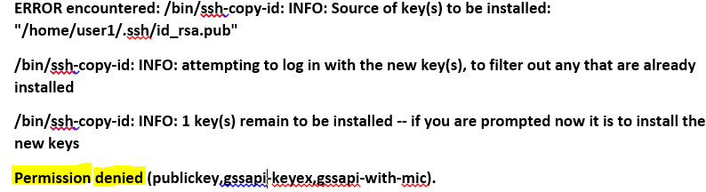

* **Solution for the above Issue: Enter as root in the Main Instance**
  + cd /etc/ssh
  + vi sshd_config
  + Set the PasswordAuthentication as yes
  + Systemctl restart sshd
* Now - ssh-copy-id -i user1@IPofAgent (It should work now)
* **To ping the Agent as user from Main Instance, below should be done**
* Vi /etc/ansible/hosts [Not vi /etc/hosts]
* Add -> [webservers] and below it, give -> IP address of Agent Instance
* Save it
* Ansible –m ping webservers
* ansible –m command –a “uptime” webservers [It should work]
* **To create a user or install httpd in Agent instances, below should be done**.
  + ansible webservers –m yum –a “name=john password=john” –s
  + There might be permission issue. If so, do the below
  + groupadd sudo
  + sudo usermod –a –G sudo user1
  + visudo
  + Add -> % sudo ALL=(ALL) NOPASSWD:ALL [Below Same thing without a password –under #%wheel ALL=(ALL) NOPASSWD:ALL]
  + Reboot both the instances or exit and login back
  + Try -> ansible webservers –m yum –a “name=john password=john” –s [Should work now]
* How to deploy war file in hosts – is shown as below:
* 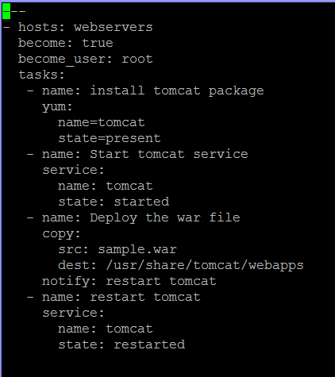
* Ansible-playbook playbook3.yml --syntax-check
* Ansible-playbook playbook3.yml
* Deploy the sample war file using sudo wget and paste the URL in root.
* Now the script runs successfully, the war file is deployed. Host IP:8080/sample
* 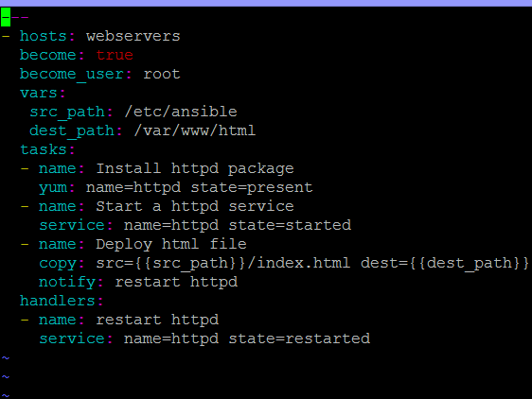
* ansible-playbook playbook1.yml --syntax-check
* ansible-playbook playbook1.yml
* **Roles are re-usable**.
* You can convert playbooks in to roles.
* cd /etc/ansible/roles
* ls
* Sudo mkdir tomcat
* cd /etc/ansible/roles/tomcat/
* sudo mkdir files handlers meta tasks vars
* Now go to tasks (cd tasks)
* 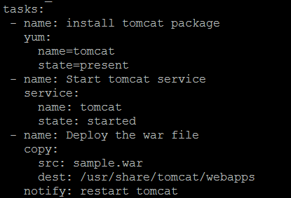
* Give name for file as main.yml [sudo vi main.yml]
* Now similarly go to handlers and create the file with same name and paste handlers are there
* 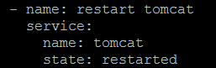
* Now go to files. [cd .. and cd files]
* Now copy the file to files. [sudo cp /sample.war .]
* Now come to roles
* Cd /
* Cd /etc/ansible/roles
* Create file site.yml
* 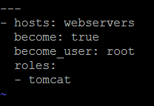
* Sudo yum install tree
* Tree
* 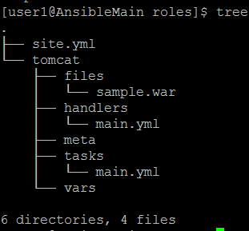
* Now Navigate in to roles under ansible. IN roles there is site.yml
* 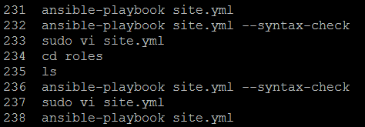
* The script is successfully executed.
* Check the IP:8080/sample -> war file is deployed.
* Create roles
* 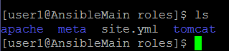
* Site.yml is the key
* 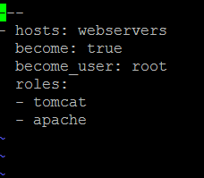
* If you go to apache, there will be directories with names files, handlers, meta, tasks, vars. In each one, there will be main.yml file with appropriate script statements
* When you execute site.yml, all the inside names tomcat means all the related ones will run and apache, all the related ones will run.
* You can get many roles from <https://galaxy.ansible.com/>
* Go in search and type Jenkins.
* 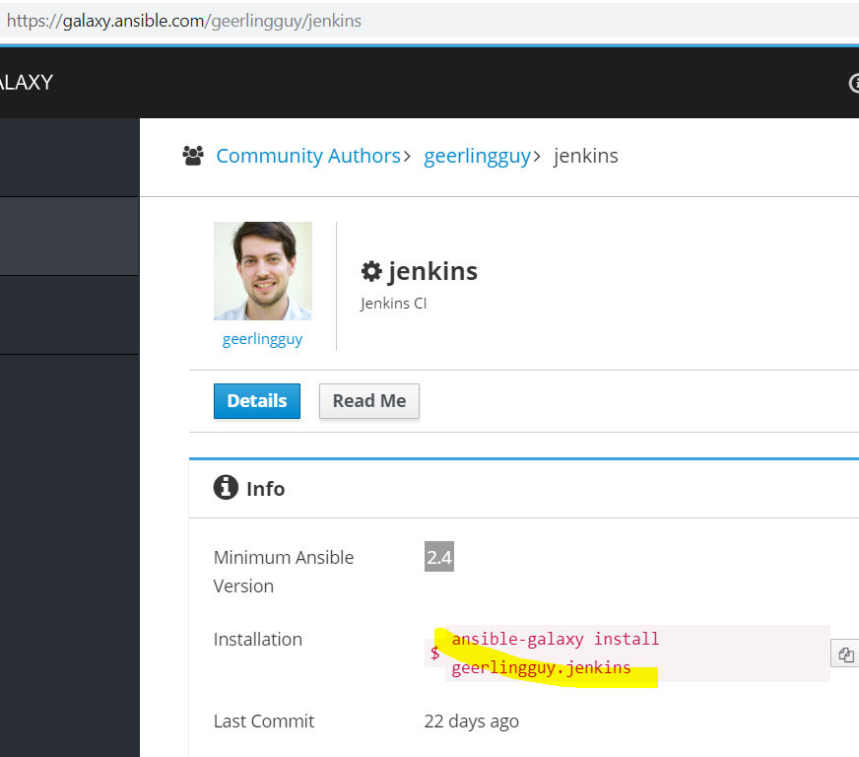
* Install the role in to your system under roles directory
* 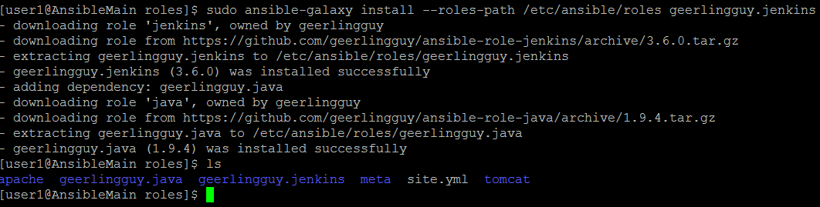
* Now in site.yml, give the below
* 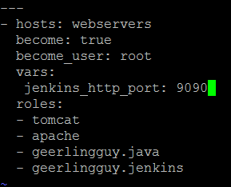
* Why – port 9090 ….as tomcat is on 8080, and index.html is on IP directly, we are directing Jenkins to 9090.
* **Below is the output**:
* 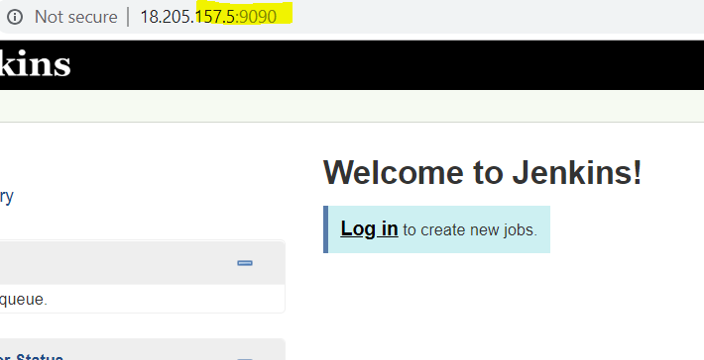
* 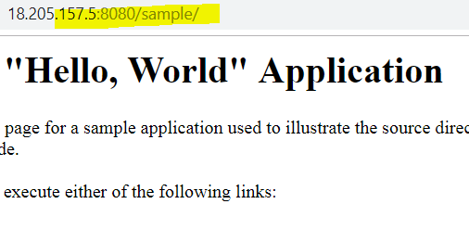
* 
* You can create a role under roles directory from ansible-galaxy 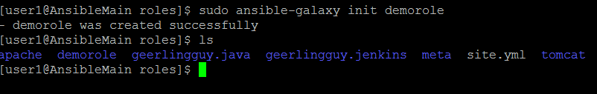
* **Note the difference**
* Ansible Roles : Puppet Modules
* Ansible Playbooks: Puppet Manifests
* Ansible Modules: Puppet Resources